Version 2026-04-03 09:04, Eric Pohl

Post-processing

Water level
The information on observed base level (the identified true water level in the field) is required in the parameter file (07 - Software for post-processing) within the renkulab project presented in the previous chapter. The water and atmosphere files are first in the instrument specific format. Within the respective software they can be exported as CSV files. The CSV files should then be prepared. The preparation consists of removing file endings, like the string “End of file”, or “Logger detached”. The file should in the end only consist of columns containing dates, and data. Before you apply any of these operations, make sure to make a copy of the original files!
Next, the water file needs to be cleaned. The loggers run the entire year even when the water is frozen. The loggers have a temperature sensor that allows to identify when the water was frozen; also, the pressure signal is usually increasing very strongly when the water in the housing tube is freezing. Sometimes this is not very clear, especially when the temperature is around 0ºC and some diurnal variation is still visible. This occurs usually in late autumn and late spring. When in doubt, it makes sense to remove the water pressure data – this has little effect on the overall calculated water amount because these are usually low-flow periods.
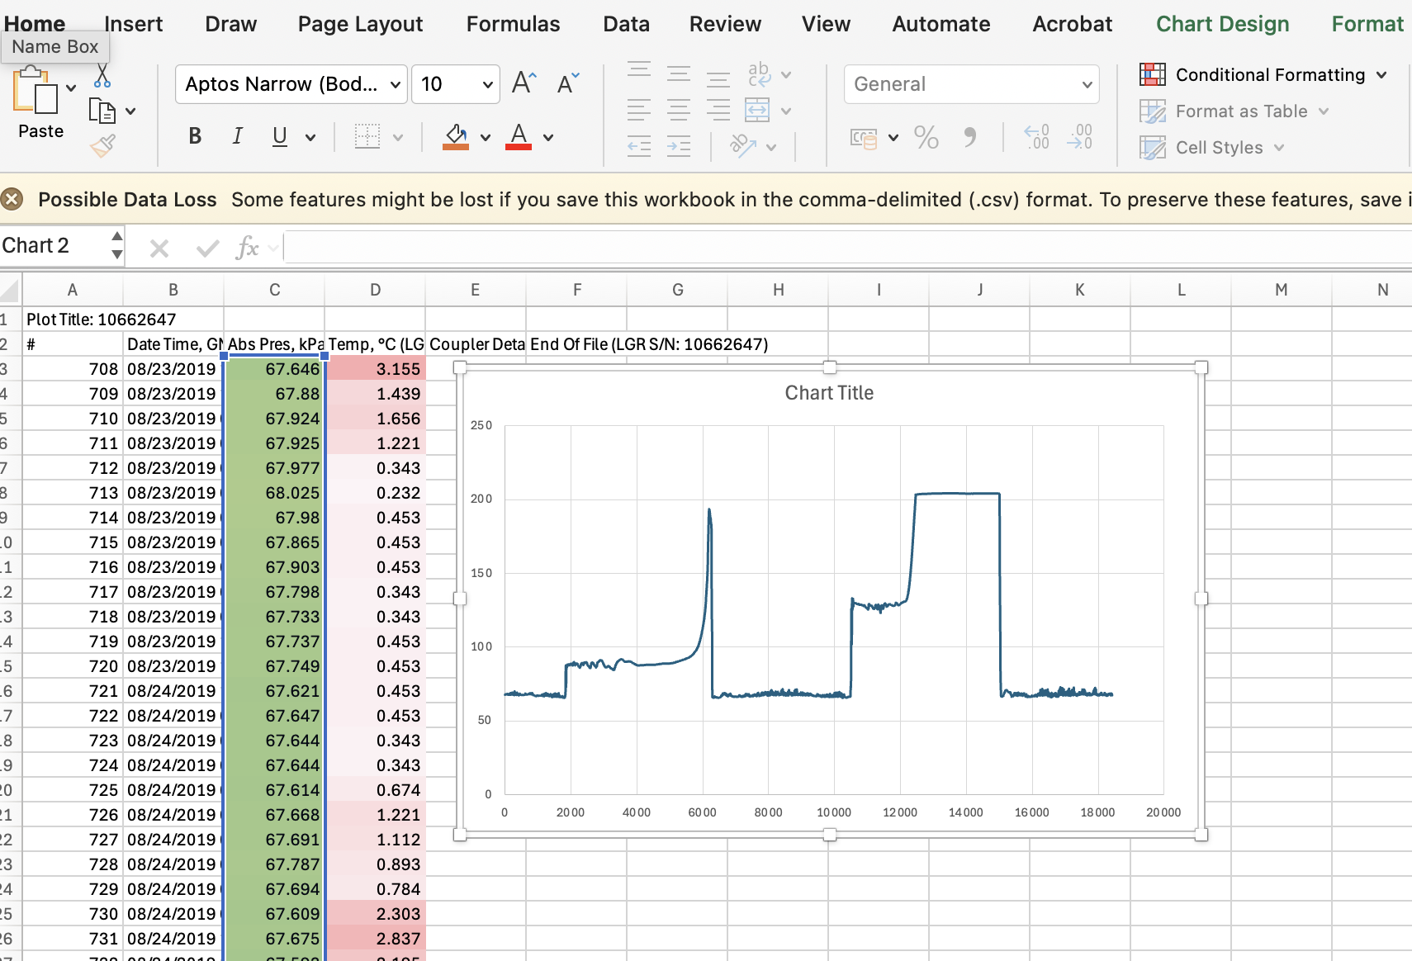
Figure 1: First cleaning of water level data. Conditional Formatting of the columns of pressure and temperature to identify frozen periods.
Figure 1 shows a water level pressure file after exporting it from the instrument software and loading it into Excel, The columns for pressure (2nd column) and temperature (3rd column) are formatted so they show low and high values in different colors (“Select column > Conditional Formatting > Select a color scale”). The graph (“Insert > Scatter > Scatter with straight lines”) shows two distinct periods with very high values and strange behavior; these are the frozen periods.
When looking into more detail (Figure 2), the color coding shows a clear and abrupt change. The temperature shows at the same time freezing temperatures. This is a clear sign that the water was frozen, and the pressure data should be deleted.
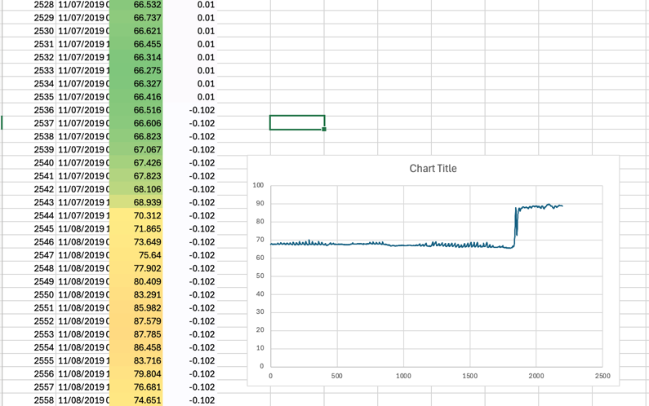
Figure 2: Water level signal with onset of freezing.
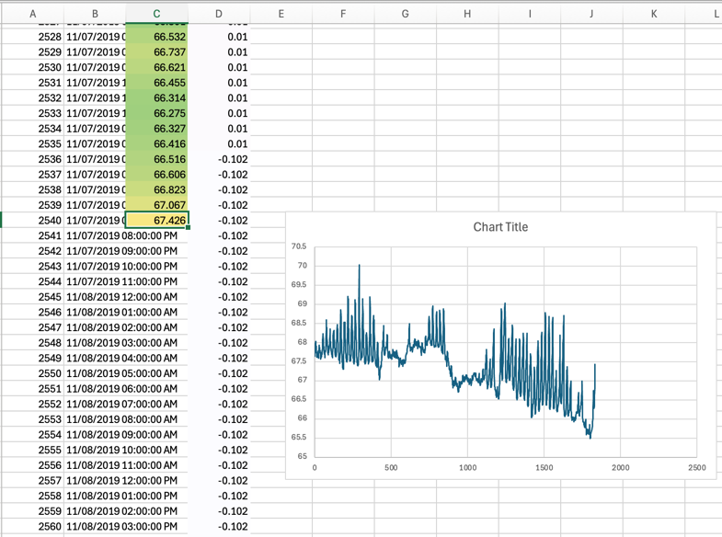
Figure 3: The same data as in Figure 2 but with the data deleted for when the water was frozen. The temperature data is kept!
Figure 3 shows the same data after deleting the pressure data when the water was frozen. Now the diurnal cycle becomes visible. This step must be performed for the entire time-series. Save the resulting file again as CSV file (File > Export/Save as > Comma separated values). And name the file so it reflects your processing. In the presented example this would be Level 2, and the resulting filename could be “KG_G354_water_2019-2021_L2.csv”.
Excel might be messing with the date format. Make sure you keep the existing data and time format. The Python program allows for some variability, but it should not vary too much.

Atmosphere pressure
The atmosphere pressure data only needs to be clipped to the same period (same start and end) as the water level file. No pressure data needs to be deleted in the atmosphere file.

Homogenization of water level data
The prepared and cleaned files need to be placed into the folders “atmo” and “wl” respectively with the data folder for your field site. In our example, this is all under:
HOBO/data/KG_G354/
For your own site and data, you can create a new folder under data/. This folder requires also the two sub-folders “atmo” and “wl”. Note: The renkulab project is not saving your data. This means that if you stop the project and restart it, all data and all changes will be gone. At the end of Chapter 7, you find the installation instructions of the R and Python software for your onw computer, where the changes are not reset.
The actual correction of the water level using the observed true water depth as a reference (“base level”), and by subtracting the atmospheric pressure are performed in the renkulab environment. We prepared the program so that it works for Glacier 354 and some other glaciers in Kyrgyzstan. If changes in water level between two different years (when switching the water level loggers) are very high, the program might produce errors. In that case, you can try to run the program for only a single year. To do so, remove all files but the file for your desired year for atmo and water (folders “atmo” and “wl”). Try to run the program again. We will help if you encounter problems. The reason to have the Python program and not do it manually with Excel (possible) is to combine automatically different years.
To do everything manually in Excel, combine the water pressure (column 2) and atmospheric pressure (column 3) into a single Excel spreadsheet. Make sure the first column is the date and time. And make sure you add the data, so they are correctly matching the date and time stamps.
Next, create a new column in which you subtract the atmospheric pressure from the water pressure. To do so create in the column 4 an expression with “=”, and select the value from column 2 “-“ value from column 3. Extend and apply this expression to then entire column 4. This can be done by copying the cell (Ctrl+c), jumping to the end of the column (scroll or Left button, Ctrl+Down, Right, Hold Shift + Ctrl Up, Ctrl+v). This is the atmosphere pressure corrected data. To remove the observed true water depth, look for that data entry in the date-time column. Check the value of the just created water level (column 4). Calculate the difference to the true value and remove the difference from all cells. Do this in a new column (column 5) by again starting an expression with “=” and select the value left in column 4 and add the “ – X”, where X is the difference that you have identified. Do this for every year.
Next, you need to homogenize the individual time-series. If you look at the last value of one year and the first value of a next year, you will likely see a difference. Optimally there should be some overlapping days; this overlap period you can use to see how much difference there is and correct the consecutive time-series by subtracting this identified value. Continue this for all time-series.
In the Python program this is all done automatically. The resulting corrected water level is written into CSV files and graphs are produced.

Water Level - Discharge relationship (rating curve)
The rating curve is created using a separate Python program that is available on rekulab.io. Check the website (https://github.com/pohleric/mountain-hydrology-workshop-2026/tree/main) for the link to this project. The program will align the corrected water level data with the discharge estimated from the tracer experiments. It is required to have both measurements in a dedicated Excel file. For the example of Glacier 354, this file is in DISCHARGE/Q-FL/. For the station from 2019 trough 2025 this is KG_G354-old_Q-FL.xlsx. It has a spreadsheet called “clean” where these measurements are aligned. In the first spreadsheet (Sheet1) of that file, all available information is collected. Some of the measurements are of bad quality. This will become apparent when used in the calculation. Therefore, a second spreadsheet with the name “clean” is available. Here you can choose which of the measurements you want to include in the calculation. Simply copy the values from the “Sheet1” to the second spreadsheet. If you run the calculation you will be able to see which measurement points are problematic and you can delete those measurements without compromising the original set of measurements. For the calculation of the rating curve, however, the program requires exactly one measurement of discharge per water level.
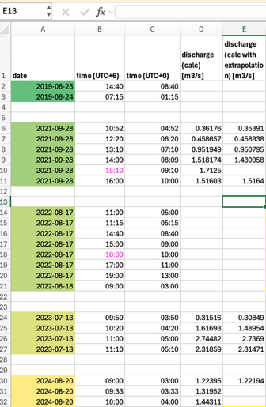
Figure 4: Format of the combined discharge (Q) and water level (corrected) Excel file in the spreadsheet called “clean”. This is read in by the program to calculate the rating curve.
The program will try to obtain a best fitting relationship using a polynomial for the relationship according to the equation presented in Chapter 1.4. The depth at which no flow is occurring (H0) has to be estimated. This can be done automatically if enough data points are available or by guessing a value. Inside the program you will find the variables called H0_bounds_min and H0_bounds_max (Figure 5). Here you can provide an upper and lower estimate about the depth where no flow is occurring. If you are uncertain, you can provide a large value range.
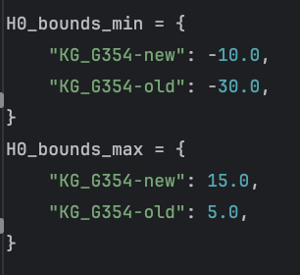
Figure 5: H0 range to be tested in the fitting process. H0 (the depth at which no flow is occurring anymore) can be set very broadly. In this example it's a total of 25 cm and 35 cm, respectively, for the old and new station at G354.
If no measurements are avaiable for a specific year, the program will use a previous year’ rating curve. In Figure 6 you see the finally obtained rating curve of 2024 for G354. The uncertainty of discharge are predefined in a very conservative way as 30%. This is due to the large uncertainties encountered in several years regarding the FL30 discharge estimates. This can be changed manually (advanced understanding of the code structure necessary – can be found in the “fit_from_dataframe” function within the rating_curve program).
Figure 6: Obtained rating curve from matching water level - discharge pairs for G354 in 2024.

Continuous discharge time-series
After the previous step, the program will read in the corrected water level time series and apply the calculated relationship (rating curve), including the uncertainty bands. This yields a full series of discharge for the best fit, but also a low and high estimate. The three estimates “Q_mid”, “Q_low”, and “Q_high”, as well as all original measurements can finally be found in the L4 folder inside the DISCHARGE/ folder.

